Use Case Diagram

Special moves

User1

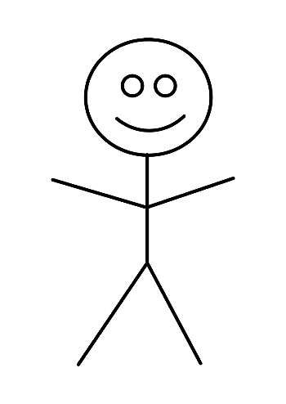

promote a

piece

perform castling

perform en passant

User2